|  |
| --- |
| Student Concerns and Complaints: Formal Stage  **Concern Review Form** |

In accordance with the formal stage of the University’s **Code of Practice on Student Concerns and Complaints**, a student may submit this form to request that his/her concerns be reviewed by the Head of School or Professional Services (or nominee) or by Student Conduct, Complaints and Appeals.

The **Concern Review Form** may be submitted if the student’s concerns remain unresolved following initial consideration (where appropriate) by a relevant member of staff. The form must be submitted within **one month** of the date of the initial response from that member of staff (where applicable).

The Code of Practice on Student Concerns and Complaints and this form are available at: <https://intranet.birmingham.ac.uk/as/registry/policy/complaint-appeal/complaints/index.aspx>

Students are advised to consult Guild Advice at the **Guild of Students** for advice and support in relation to raising and pursuing their concerns: [guildadvice@guild.bham.ac.uk](mailto:guildadvice@guild.bham.ac.uk) or 0121 251 2400 or <https://www.guildofstudents.com/support/guildadvice/who-we-are-guild-advice/>.

|  |
| --- |
| **Section A: Student Details** |

|  |  |
| --- | --- |
| Name | Christopher Hill |
| ID number | 2093256 |
| Programme of Study | PhD Music Performance Practice |
| School or Department | Music |
| E-mail address | cjh956@student.bham.ac.uk |

|  |
| --- |
| **Section B: Details of concerns** |

Please explain your concerns clearly, including the following information:

* What your concerns are and why;
* A description of the outcome so far (if you have already raised the matter with an appropriate member of staff);
* Why you feel that your concerns are unresolved

|  |
| --- |
| Please see attached document. |

(Please continue on a separate sheet if you need to. Please number the pages clearly.)

|  |
| --- |
| **Section C: Redress** |

Please state clearly what redress you are seeking (e.g. an apology, a return of overpaid fees):

|  |
| --- |
| The impact of Mr Rosina’s conduct towards myself and my fellow students has left me in a position where, even should an apology be presented, I feel unable to engage with, or be involved in, the ensembles which Mr Rosina conducts, adjudicates, or has a leadership role within.  My primary goal in the submission of this formal complaint is therefore, insofar as I am able, to safeguard other members of the Music Department and Music Society from similar treatment by Mr Rosina. To this end, I require a formal investigation into the professional conduct of Mr Rosina both in his capacity as Director of Orchestral Studies, and in his various roles within the University of Birmingham Music Society, and appropriate action be taken on the basis of the findings of such an investigation. |

|  |
| --- |
| **Section D: Supporting documentation** |

Please ensure that you have enclosed any relevant supporting documentation to help the Investigating Officer consider your concerns fully. This should include the following:

* *Evidence or other documentation which supports the concerns you are raising*
* *Emails or other correspondence in which you have already raised your concerns with an appropriate member of staff (if applicable)*
* *The response from that member of staff (if applicable)*

If you have enclosed any other documentation, please indicate the nature of the documentation (e.g. email correspondence):

|  |
| --- |
| * Formal Complaint Document, containing appendices of complaints and testimony submitted to me for submission by fellow students (PDF) * University of Birmingham Harrassment and Bullying Policy (PDF) * Chris Hill Reasonable Adjustment Plan (PDF) * Email correspondence regarding requested absence from orchestra (.eml) * Email correspondence, unanswered by Mr Rosina, about information for soloist competition (.eml) |

|  |
| --- |
| **Section E: Further Information** |

|  |  |  |  |
| --- | --- | --- | --- |
| Have you sought advice from Guild Advice when completing this form? | Yes | No | prefer not to say |

|  |  |  |
| --- | --- | --- |
| Do you feel you require specific disability related support with this process? If so, please give details.  N/A | | |
| If yes to the above, are you happy for this information to be shared with your School? | Yes | No |

Please ensure that you have completed all sections of this form and enclosed all relevant supporting documentation.

Please submit your form and supporting documentation to [student-complaints@contacts.bham.ac.uk](mailto:student-complaints@contacts.bham.ac.uk)

Please note that, by signing this form, you are authorising the Investigating Officer to consider this form and related information regarding your concerns.

Signature: 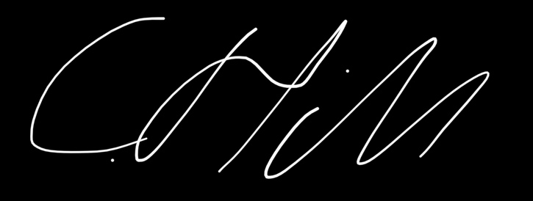 Date: 20/12/2022